Practice Test
- Create a website for an electronic shop, called Argus Technology, who sells electronic devices. Make sure that you use the appropriate HTML, CSS and JavaScript tags.

- There are 6 webpages on the site:
No. | Page Title | File name
1 | Home | Index.html
2 | About Us | About.html
3 | Gallery | Gallery.html
4 | Order | Order.html
5 | Contact Us | Contact.html
6 | Site Map | Sitemap.html

- Create these 6 HTML files and name them according to the File name specified in the table above.
- Specify the appropriate title for each page

- The general layout of each webpage is
Header
Footer
Menu Bar
Page Content

- The header of each webpage is an image stored in header.jpg

- All the text, except for Title and Section title, in the webpage should be formatted as the following:
  - Font family: Arial
  - Font size: 12px
  - Font colour: #999999

- The menu bar of each webpage should look like the image below.
Home
About Us
Gallery
Order
Contact Us
Site Map

- Each menu item in the bar should have rounded corners, black text and blue border.
- When a user clicks on a menu item, the relevant file should be displayed. For example: clicking About Us should display About.html file.
- When a user hovers on a menu item, change the colour of the text to White and the background colour to rgb(55,96,146)

- The footer of each webpage should specify your Name, e-mail and Student ID, and formatted like the following:
John Smith | e-mail: jsmith@unitec.ac.nz | ID: 0222662

- The content of the main home page (Index.html) should be a slideshow of all the 6 images that are stored inside the Slideshow folder as shown below.
  - Clicking the next and previous buttons would show the next and previous images on the list.
  - When a user hovers over the next or previous buttons, it should display “View the next item on the list” and “View the previous item on the list”, respectively.
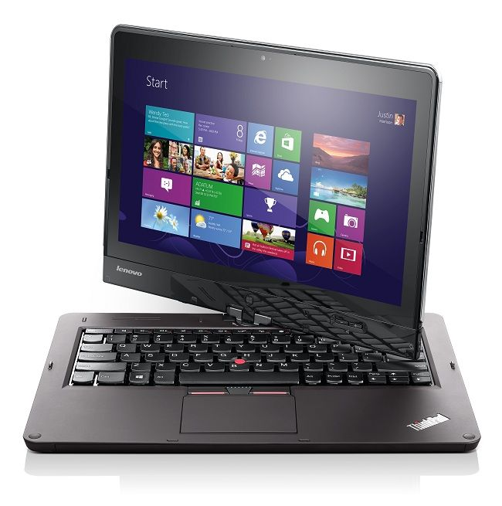
Previous
Next

- The content of the About Us page (About.html) should look like the following:
About Us

Argus Technology was established in 1988 and provides IT hardware, software and support to some of New Zealand's largest organisations.

Our primary focus has been in the education sector and our customers include some of the largest IT users in New Zealand including The University of Auckland, AUT University, Unitec, University of Canterbury, Manukau Institute of Technology, Lincoln University, University of Otago, Otago Polytechnic, Massey University, Victoria University, Te Wānanga o Aotearoa, SIT, UCOL, CPIT, BOP Polytechnic, NorthTech and EIT.

Commerical customers include Jade Software, Duncan Cotterill, Tait Electronics and Pumpkin Patch.

- Partners

  - Adobe Gold Partner
Argus Technology is currently a Gold Partner with Adobe, thus allowing us to offer their full range of software including large licensing agreements, at aggressive price points backed by educated/knowledgeable sales & support staff.

  - Apple Authorised Reseller / Apple Authorised Education Reseller
Argus Technology is one of the few select Apple Authorised Resellers. We also are an Authorised Educational Reseller and an Authorised Service Centre (Christchurch and Dunedin).

Argus Technology is also unique in New Zealand as a member of the Apple Consultants Network where we have certification in Mac, Servers and Network, Mobility and Training and Professional Development.

- Industry Services

- Lenovo Direct Partner
When Lenovo aquired the manufacturing rights for the ThinkPad and ThinkCenter products from IBM, Argus Technology continued this already strong relationship. These products have been proven both in the enterprise and consumer sectors. We are a Direct Partner with Lenovo and one of their largest customers in New Zealand.

- Microsoft Gold Partner
Argus Technology is a Microsoft Gold Partner. We are also the only local OEM who is accredited as an Education Large Account Reseller allowing us to sell the Microsoft Campus Agreement direct to tertiary educational institutions.

- The content of the Gallery page (Gallery.html) shows list of images in the Slideshow folder. Hovering over the image, should display the table of descriptions related to the image. Otherwise, the table should disappear. You may select any price for each of the tablets. For example, when the mouse is over the IBM tablet image (image3.jpg), the Gallery page would look like the following:
Gallery

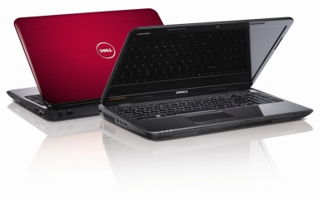  Dell | 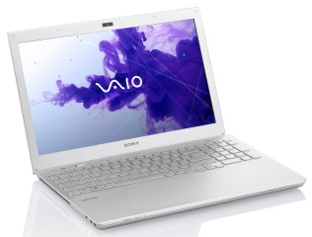  Sony | 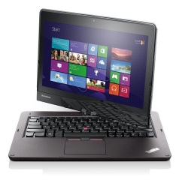  IBM
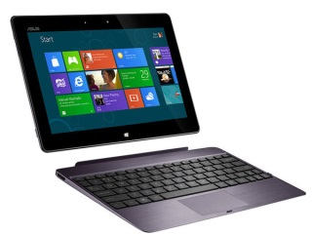  Asus | 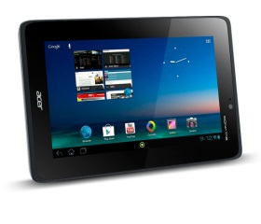  Acer | 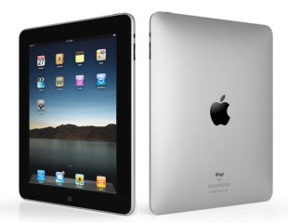  Apple

Descriptions

Features | Values
Filename | Image3.jpg
Brand | IBM ThinkPad
Colour | Brown
Price | $1500

- The content of the Order page (Order.html) is a purchase form that looks like the following: (Use the correct input type and ensure that you validate the answer accordingly. Fields with * must be filled)
Purchase Order

Name: *
e-mail: *
Phone:
Country: | New Zealand
Laptop brand:*
Number of items: * | 1
Operating System: | · Windows 8  Windows 7  iOS
Comments:
Newsletter: |  e-mail  SMS  Mail

- The content of the Contact Us page (Contact.html) should show your contact details

- Create the sitemap for this website in Sitemap.html

- Create another style sheet, where the menu bar is vertical and located on the left side of the content panel, and create a button that would switch between the 2 style sheets

- Save your work

